1. **Learning goals**

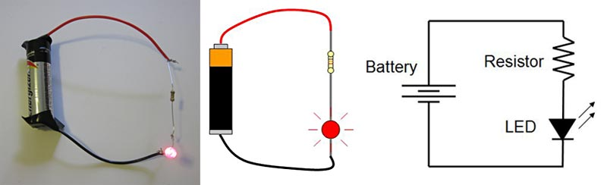

**Electronics**

**GOALS:**

1. Electricity in our everyday lives.
   1. Describe different ways electricity is generated.
   2. Understand the impact electricity has in our lives and interactions.
2. Representation of a Simple Circuit
   1. Understand the function and different parts of a simple circuit.
   2. Understand and represent the parts of the circuit and the current direction it has.
   3. Learners should be able to use the acquired knowledge to create and fix a project.
3. Measuring Electricity
   1. Measure electricity using different tools
   2. Control electricity by using different tools and materials.
   3. Read simple representations of electric circuits
   4. Document projects using schematics.